**https://cwiki.apache.org/confluence/display/Hive/SerDe**

**Add the SerDe snapshot jar in hive**

add '/usr/local/hadoop/hive-0.12.0/lib/hive-serdes-1.0-SNAPSHOT.jar';

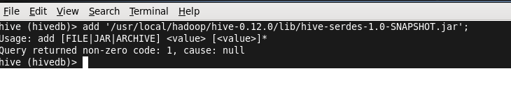

Create a schema for JSON data: